**1.Modelo RF5_Indeg Apoio Controlo1 Reparacion2 DiqPriqCint X All var**.

***Instrucciones modelo***: **test size = 0.32 ; rd_state = 3**

***Variables indep select to fit***:

variables = [   'id', 'Indeg_RedeRisk_Cen',    'PC1_Distance_Pro',    'Degree_RedeTotFamil',

    '1_VarExp_Moranca',    '9_VarExp_Atri_IndMelhorTecnDiqCint',    'Area_bolanha',

    'OutDeg_IntimAmigos_',  'OutDeg_RedeRisk_Cen',  'OutDeg_RedeConfianc'  ]

***Model performance (scores):***

Mean Squared Error: 4.1667

R^2 Score: 0.5784 (In Excel: R2 = 0.5885 ; y = 0.5114 X + 2.3619)

**Model tot:**

Mean Squared Error (MSE): 2.2868

Root Mean Squared Error (RMSE): 1.5122

Mean Absolute Error (MAE): 1.0930

R^2 Score: 0.8126

Pearson Correlation: 0.9212

***Interactions***:

| **Interacción** | **Importancia** | **Dirección** |
| --- | --- | --- |
| 0 | (9_VarExp_Atri_IndMelhorTecnDiqCint, OutDeg_Re... | 1.795277 | 0.092190 |
| 1 | (OutDeg_IntimAmigos_, OutDeg_RedeConfianc) | 1.593582 | 0.202129 |
| 2 | (Area_bolanha, OutDeg_RedeConfianc) | 1.442565 | -0.001080 |
| 3 | (OutDeg_RedeRisk_Cen, OutDeg_RedeConfianc) | 1.442370 | 0.065697 |
| 4 | (PC1_Distance_Pro, OutDeg_RedeConfianc) | 1.423355 | -0.030522 |
| 5 | (Indeg_RedeRisk_Cen, OutDeg_RedeConfianc) | 1.409874 | 0.027806 |
| 6 | (1_VarExp_Moranca, OutDeg_RedeConfianc) | 1.391547 | -0.024280 |
| 7 | (Degree_RedeTotFamil, OutDeg_RedeConfianc) | 1.342888 | 0.117358 |
| 8 | (9_VarExp_Atri_IndMelhorTecnDiqCint, OutDeg_In... | 1.049659 | 0.071110 |
| 9 | (Degree_RedeTotFamil, OutDeg_IntimAmigos_) | 1.042553 | 0.156233 |

***Key results****:*

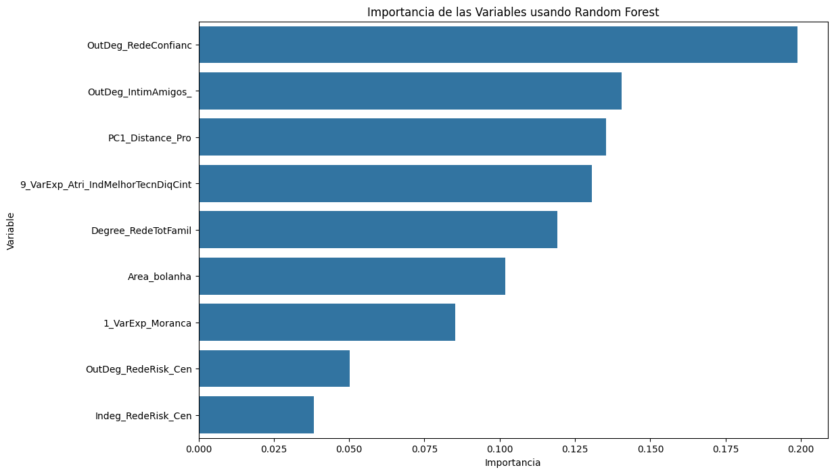

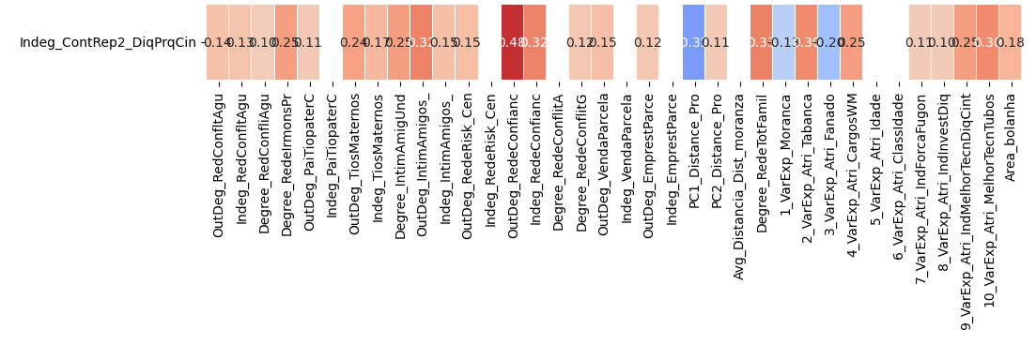

**2.Modelo RF5_Outdeg Apoio Controlo1 Reparacion2 DiqPriqCint X All var**.

***Instrucciones modelo***: **test size = 0.2 ; rd_state = 3**

***Variables indep select to fit***:

variables = [  'id',  'Degree_IntimAmigUnd',   'Indeg_RedeRisk_Cen',    'Indeg_RedeConfianc',

'PC1_Distance_Pro',  'Degree_RedeTotFamil',  '1_VarExp_Moranca', '9_VarExp_Atri_IndMelhorTecnDiqCint', '10_VarExp_Atri_MelhorTecnTubos', 'Area_bolanha',

'OutDeg_RedeRisk_Cen' ]

***Model performance (scores):***

Mean Squared Error: 4.6538

R^2 Score: 0.8950 (In Excel: R2 = 0.9059 ; y = 0.8197 X + 0.6388 )

**Model tot:**

Mean Squared Error (MSE): 1.7907

Root Mean Squared Error (RMSE): 1.3382

Mean Absolute Error (MAE): 0.8450

R^2 Score: 0.9581

Pearson Correlation: 0.9819

***Interactions***:

|  | **Interacción** | **Importancia** | **Dirección** |
| --- | --- | --- | --- |
| 0 | (Indeg_RedeConfianc, PC1_Distance_Pro) | 7.062282 | 2.087946 |
| 1 | (Indeg_RedeConfianc, 10_VarExp_Atri_MelhorTecn... | 7.020403 | 2.037218 |
| 2 | (Degree_IntimAmigUnd, Indeg_RedeConfianc) | 7.016586 | 0.060438 |
| 3 | (Indeg_RedeConfianc, Area_bolanha) | 7.015768 | 2.067087 |
| 4 | (Indeg_RedeConfianc, OutDeg_RedeRisk_Cen) | 7.013753 | 2.048536 |
| 5 | (Indeg_RedeRisk_Cen, Indeg_RedeConfianc) | 6.994664 | 0.014545 |
| 6 | (Indeg_RedeConfianc, Degree_RedeTotFamil) | 6.992696 | 2.058697 |
| 7 | (Indeg_RedeConfianc, 9_VarExp_Atri_IndMelhorTe... | 6.910999 | 2.015025 |
| 8 | (Indeg_RedeConfianc, 1_VarExp_Moranca) | 6.870582 | 2.032720 |
| 9 | (9_VarExp_Atri_IndMelhorTecnDiqCint, 10_VarExp... | 2.230375 | 0.112658 |

***Key results****:*



